**DEVELOP A WEB APPLICATION USING NODE -RED :**

**TEAM ID : PNT2022TMID23204**

1. Double-click the tab with the flow name, and call it Earthquake Details.
2. Click the hamburger menu, and then click **Manage palette**. Look for **node-red-node- open weather map** to install these additional nodes in your palette.

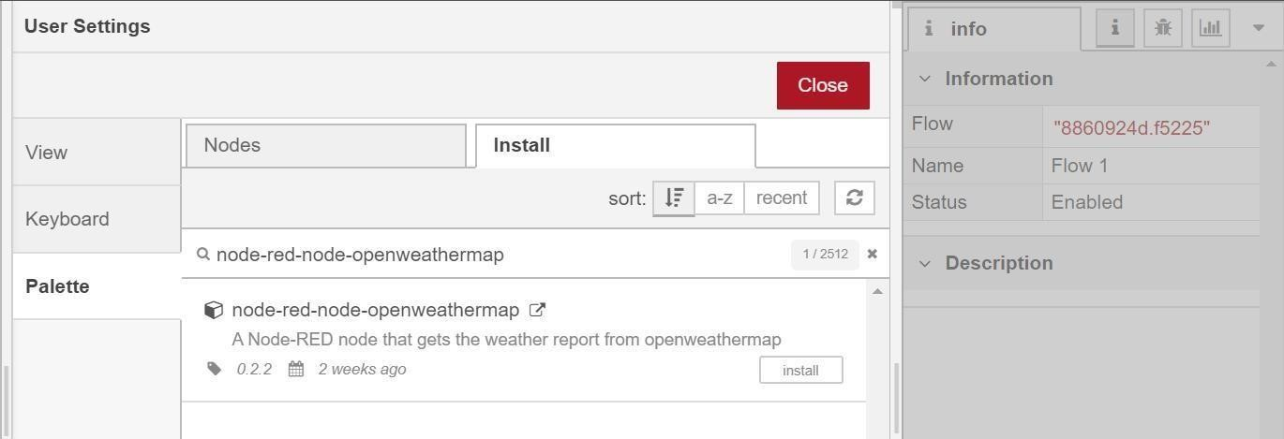

Add an **HTTP input** node to your flow.

Double-click the node to edit it. Set the method to GET and set the URL to /earthquakeinfo-hr.

1. Add an **HTTP response** node, and connect it to the previously added **HTTP input** node. All other nodes introduced in this sub-section is to be added between the **HTTP input** node and the **HTTP response** node.
2. Add an **HTTP request** node and set the *URL* to https://earthquake.usgs.gov/earthquakes/feed/v1.0/summary

/all_hour.geojson, the *Method* to **GET** and the *Return* to **a parsed JSON object**. This will allow extracting all earthquakes that occurred within the last hour. Name this node Get

Earthquake Info from USGS.

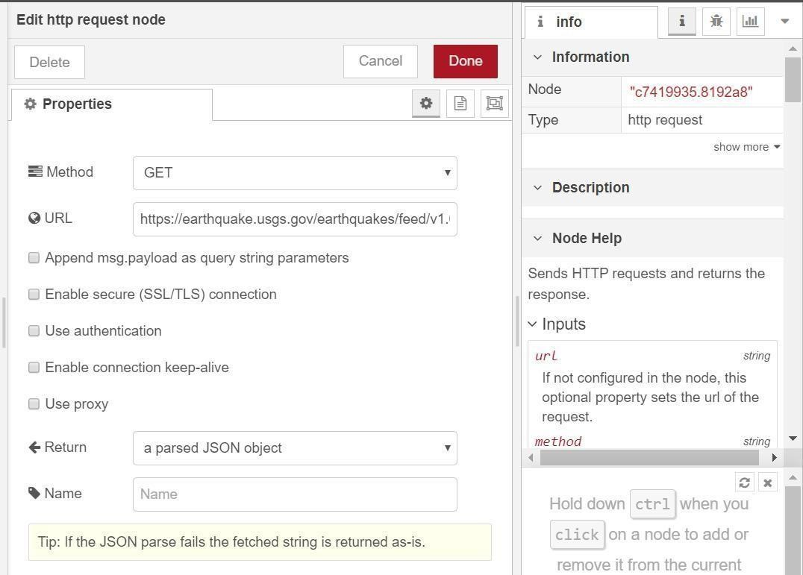

|  |  |  |  |
| --- | --- | --- | --- |
| Add a **change** node. Double-click the node to modify it. Name this node Set Earthquake Info. In | | |  |
| the **Rules** section, add rul to *Delete* msg.topic, | | es | |
| msg.headers, msg.statusCode, msg.responseUrl and msg.redirectLis | |
| t and *Set* msg.payloa | d payload.features. | | |
| {  "type":properties.type,  "magnitude": properties.mag,  "location": properties.place,  "longitude":geometry.coordinates[0],  "latitude":geometry.coordinates[1],  "depth":geometry.coordinates[2],  "timestamp": $fromMillis( properties.time, | | | |

|  |
| --- |
| '[H01]:[m01]:[s01] [z]',  '+0400'  ),  "source": properties.net  } |

the following JSONata expression.

**WEB DASHBOARD NODES FOR CREATE UI:**

Dashboards are a powerful opportunity [**to influence user behavior** a](https://adamfard.com/blog/user-behavior)nd boost retention rates. By using the data collected through research, designers can create a dashboard that displays actionable and relevant data. All this is made possible through dashboard UI design**.**

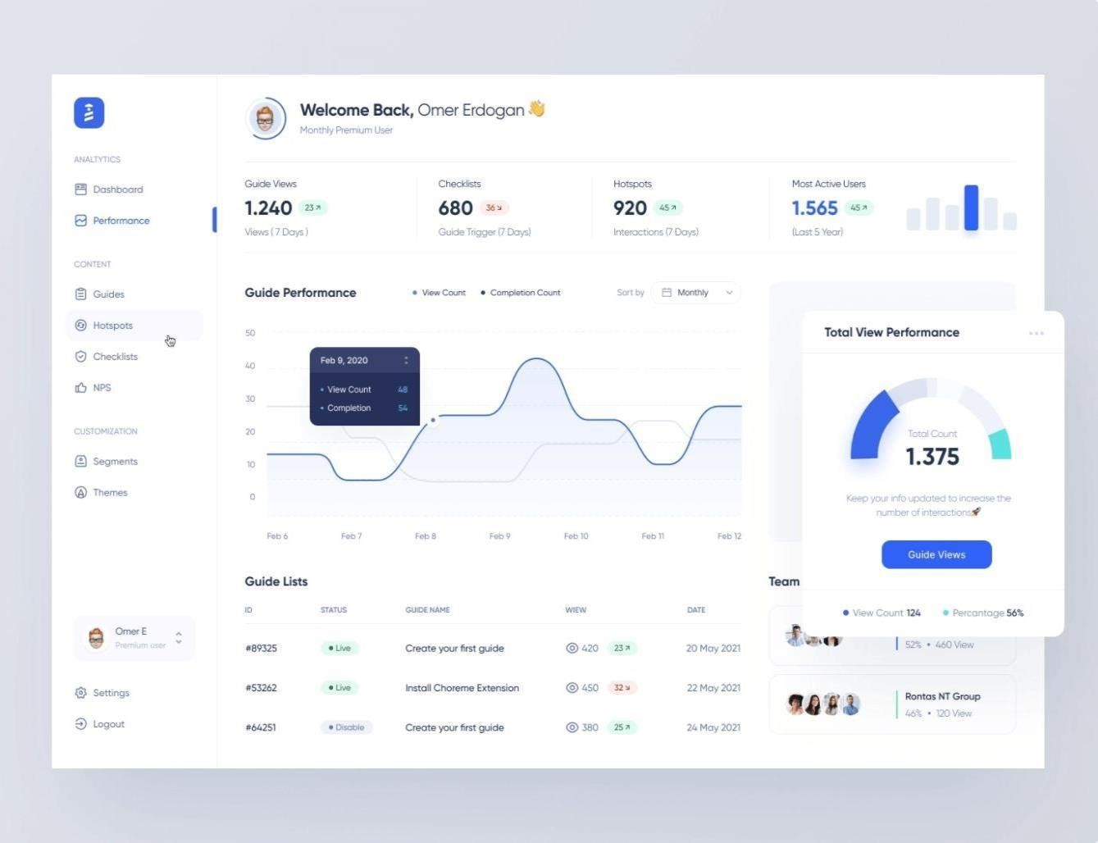

If you design a proper and modern UI dashboard, it will give the users easy access to the information they need. For this to happen, the dashboard information needs to be easy-to-scan and contain only the key information. But, with many tools available, it can be hard to make the right choice or not exaggerate with the use of features.

This is one of the many [**roles of a UX designer** a](https://adamfard.com/blog/ux-designer-role)nd as such, it demands knowing certain tricks to be handled the right way.

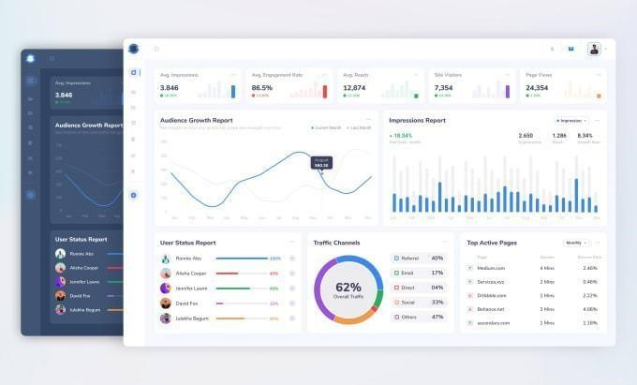

**CREATE AN HTTP REQUESTS TO COMMUNICATE WITH MOBILE APP:**

* Ensuring that the browser communicates with the required server directly.
* Ensuring that only the communicating systems have access to the messages they exchange.

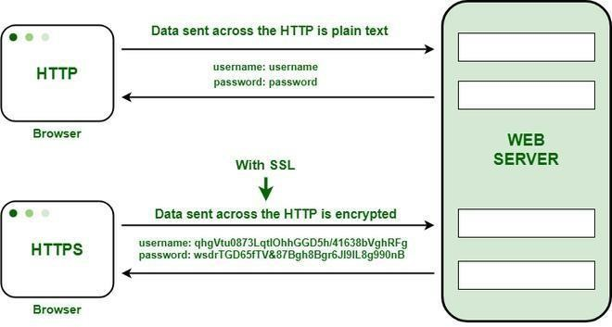

HTTP transfers data in a hypertext format between the browser and the web server, whereas HTTPS transfers data in an encrypted format. As a result, HTTPS protects websites from having their information broadcast in a way that anyone eavesdropping on the network can easily see. During the transit between the browser and the web server, HTTPS protects the data from being accessed and altered by hackers. Even if the transmission is intercepted, hackers will be unable to use it because the message is encrypted.

1. **Private Key**: It is used for the decryption of the data that has been encrypted by the public key. It resides on the server-side and is controlled by the owner of the website. It is private in nature.
2. **Public Key**: It is public in nature and is accessible to all the users who communicate with the server. The private key is used for the decryption of the data that has been encrypted by the public key.

